Task - 1 CI/CD Pipeline for a Research Experiment Booking System
Step 1: Install the required software
Check whether these tools are installed on your Windows laptop.
Software | Purpose
Java 21 | Run the Java application
Maven | Build the project
Git | Version control
Jenkins | Automate the pipeline
VS Code | Write code
Web browser | Check Jenkins

Command 1 — Check Java
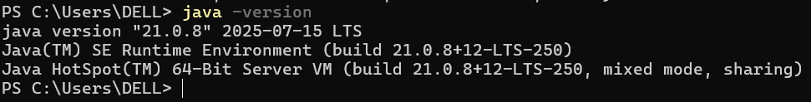
Command 2 — Check Maven
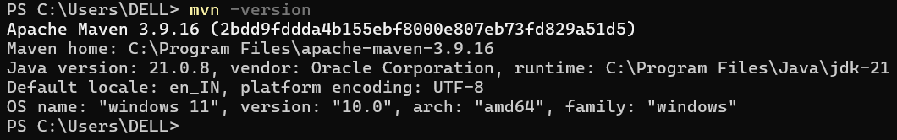
Command 3 — Check Git
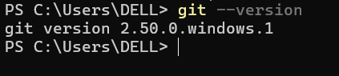

Step 2: Create the project folder

